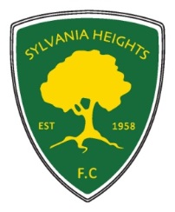Sylvania Heights Football Club
Committee Nomination Form 2017
Annual General Meeting of The Football Club of Sylvania Heights Community & Youth Club Inc.
Executive Positions: Please tick the box for the nominated position
CHAIRMAN
Vice Chairman – Senior
Vice Chairman – Junior
Secretary
Treasurer
Registrar - Senior
Registrar - Junior
Club Coach
Chief Ground Controller
Committee Positions:
Assistant Secretary
Assistant Ground Controller - 2 positions
Assistant Treasurer /Key register
Technical Director
Canteen Manager
Junior Social Ctte
Senior Social Sec
Delegates to the SSFA
Equipment/Uniform Officer
Grading Committee – up to 5 positions
Member Protection Officer
Rules Sub Committee - 3 positions
Small Sided Games Referee CO ORDINATOR
Small Sided Games Referee Mentor
Sponsorship Officer
Trail Games Officer
YEAR BOOK CO ORDINATOR
Strategic Planning and Major Sponsorship
Training Allocation

Name of Nominee: ______________________________
Nominated by: __________________________________
Seconded by: ___________________________________
Consent to accept nomination: _____________________
(to be signed by the individual nominated)
DATE………………………….

