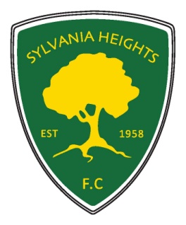Sylvania Heights Football Club
Committee Nomination Form 2018
Annual General Meeting of The Football Club of Sylvania Heights Community & Youth Club Inc.
Executive Positions: Please tick the box for the nominated position
President
Vice President – Senior
Vice President – Junior
Secretary
Treasurer
Registrar - Senior
Registrar - Junior
Club Coach
Chief Ground Controller
Committee Positions:
Assistant Secretary
Assistant Ground Controller - 2 positions
Assistant Treasurer /Key register
Technical Director
Canteen Manager
Junior Social Ctte
Senior Social Sec
Delegates to the SSFA – up to 2 positions
Equipment/Uniform Officer
Grading Committee – up to 5 positions
Member Protection Officer
Rules Sub Committee - 3 positions
Small Sided Games Referee Co-ordinator
Small Sided Games Referee Mentor
Sponsorship Officer
Trial Games Officer
Yearbook Co-ordinator

Name of Nominee: ______________________________
Nominated by: __________________________________
Seconded by: ___________________________________
Consent to accept nomination: _____________________
(to be signed by the individual nominated)
DATE………………………….

