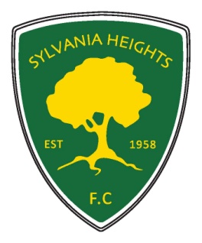Sylvania Heights Football Club
Committee Nomination Form 2019
Annual General Meeting of The Football Club of Sylvania Heights Community & Youth Club Inc.
Executive Positions: Please tick the box for the nominated position
President
Vice President – Senior
Vice President – Junior
Secretary
Treasurer
Registrar - Head
MPIO
Committee Positions:
Registrar - Assistant
Club Coach
Chief Ground Manager
Minutes Secretary
Ground - 2 positions
Assistant Treasurer /Key register
Technical Director
Canteen Manager
Social Events - Head
Social Events - Assistant
Equipment/Uniform Officer
Yearbook Co-ordinator
Social Media / Web Manager
Mini Roo Ref Co-Ordinator
Sponsorship Officer
SSFA Delegate – up to 3 positions
Sub Committees
Rules Sub Committee - 3 positions
Grading Committee – up to 5 positions

Name of Nominee: ________________________
Nominated by: ____________________________
Seconded by: _____________________________
Acceptance of nomination: ________________ (to be signed by the individual nominated)
Date ………………………….

